**TACL commands: Tandem Advance Language:**

**FUP = File Utility Program**

FUP is a utility program used for file management. FUP is a standard software package for Non-Stop Kernel. FUP:

1. Manages disk files and processes
2. Create file, display and duplicate files.
3. Load data into files.
4. Modify file attributes.
5. Purge Files

FUP supports Enscribe disk files like Key sequenced files, Entry sequenced, Relative and Unstructured Text files (including text files).

1. TACL Command> **FUP**

(*this command will bring the FUP prompt i.e. “-“. You can write the commands directly on the FUP prompt*)

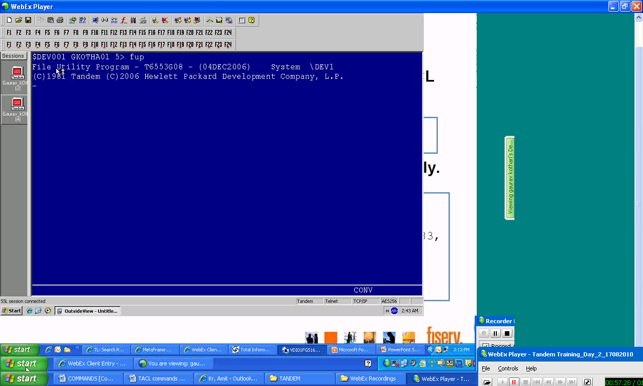

1. TACL Command> FUP $*.*.*

(*this command will show all the files available in all the volumes and sub-volumes*)

1. TACL Command> FUP info t?st

(*this command will search all the files starting with character “t” whose second character is not know but ends with “st”*)

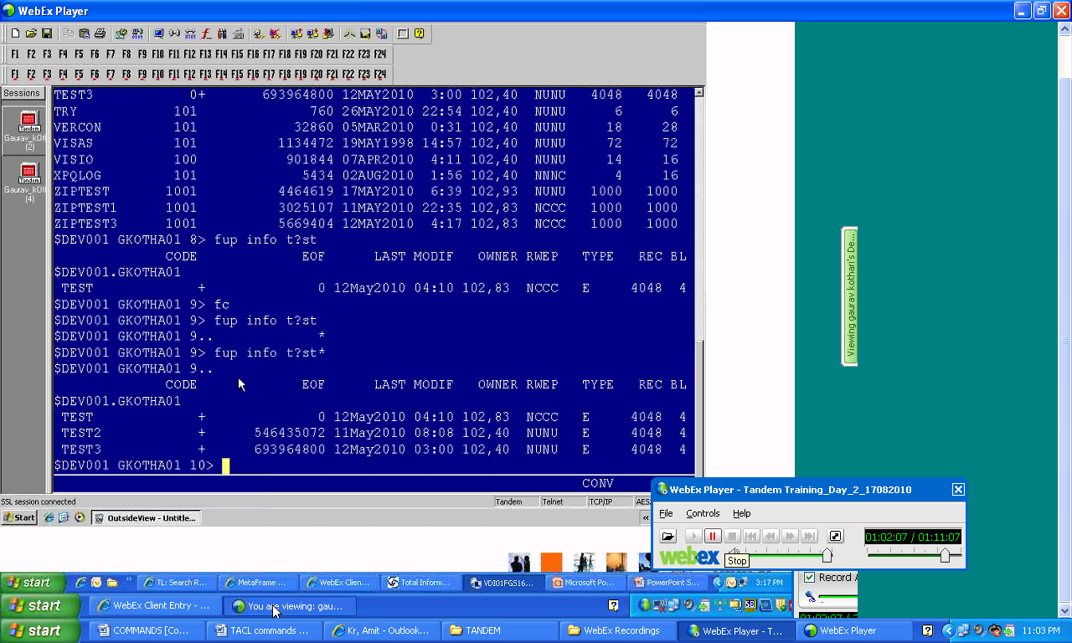

1. TACL Command> FUP info test, detail

(*this command will display you file details e.g. file type, database, format etc.*)

**1 page = 2048 Bytes,**

**1 Block = Bunch/collection of pages,**

**1 Record =No. of Bytes required to store one record length. Default = 80Bytes**

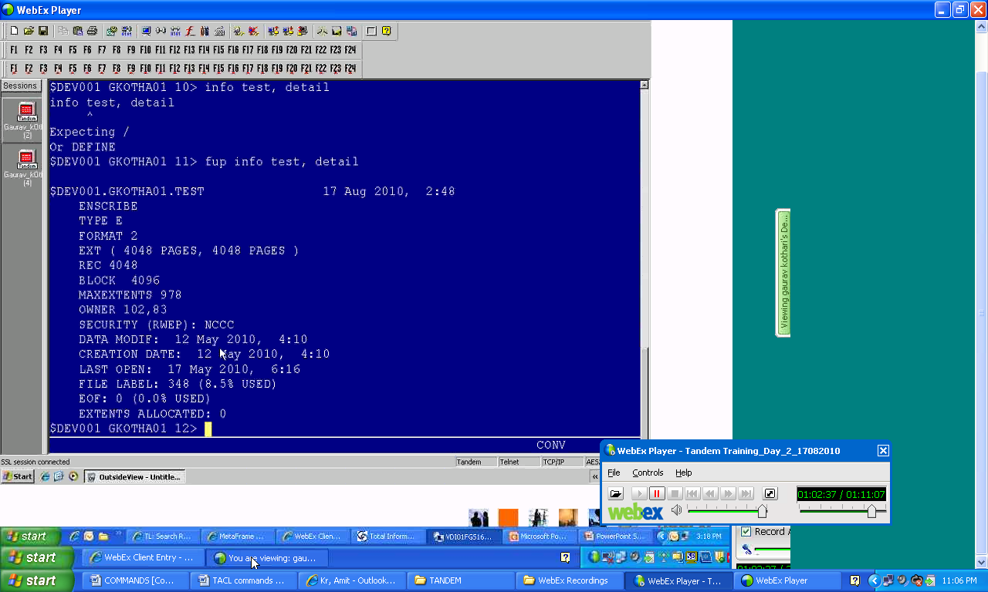

1. TACL Command> FUP DUP Test, $dasd.ancm2.*

(*this command will create a duplicate file with the same name i.e. “Test” in the volume and sub-volume “$dasd.ancm2”*)

FUP DUP = Command

Test = FileName

$dasd = Volume

Ancm2 = Sub-volume

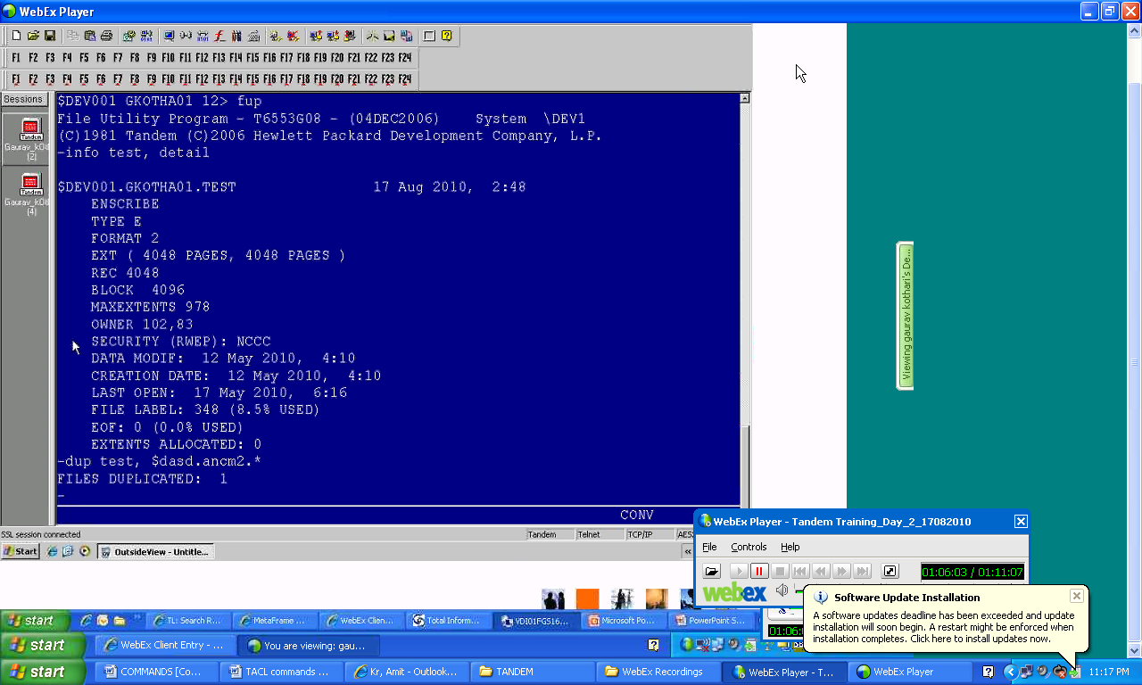

1. TACL Command> FUP DUP Test, $dasd.ancm2.*purge

(FORCE Copy, if the file exists in the volume and sub-volume $dasd.ancm2 then it will delete it first and then will copy the file with the name “Test”)

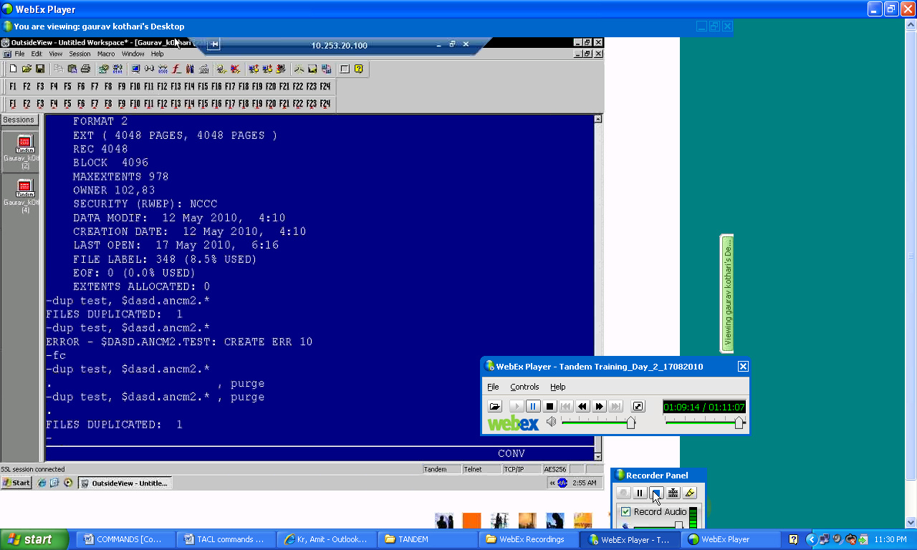

1. TACL Command> FUP DUP TEST, TESTBACKUP

(*this command will copy/backup the existing test file with another name Testbackup*)

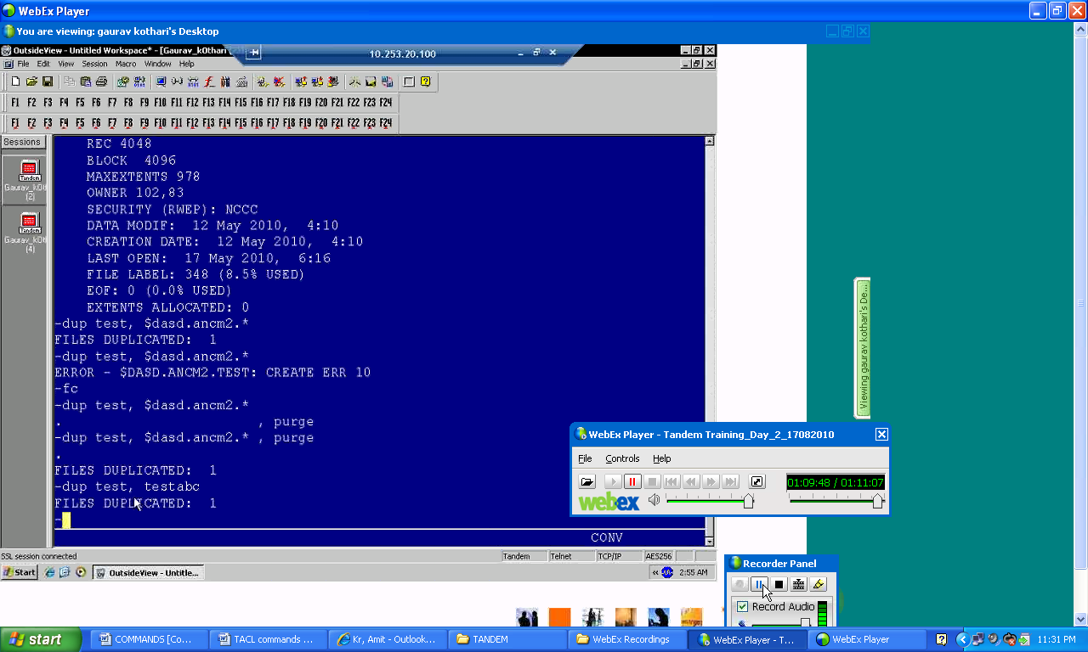

1. TACL Command>**FUP Rename <oldfilename>, <newfilename>**

(*this command will rename the file name cmdmmb to cmdmmb1 as per the screen print provided below*)

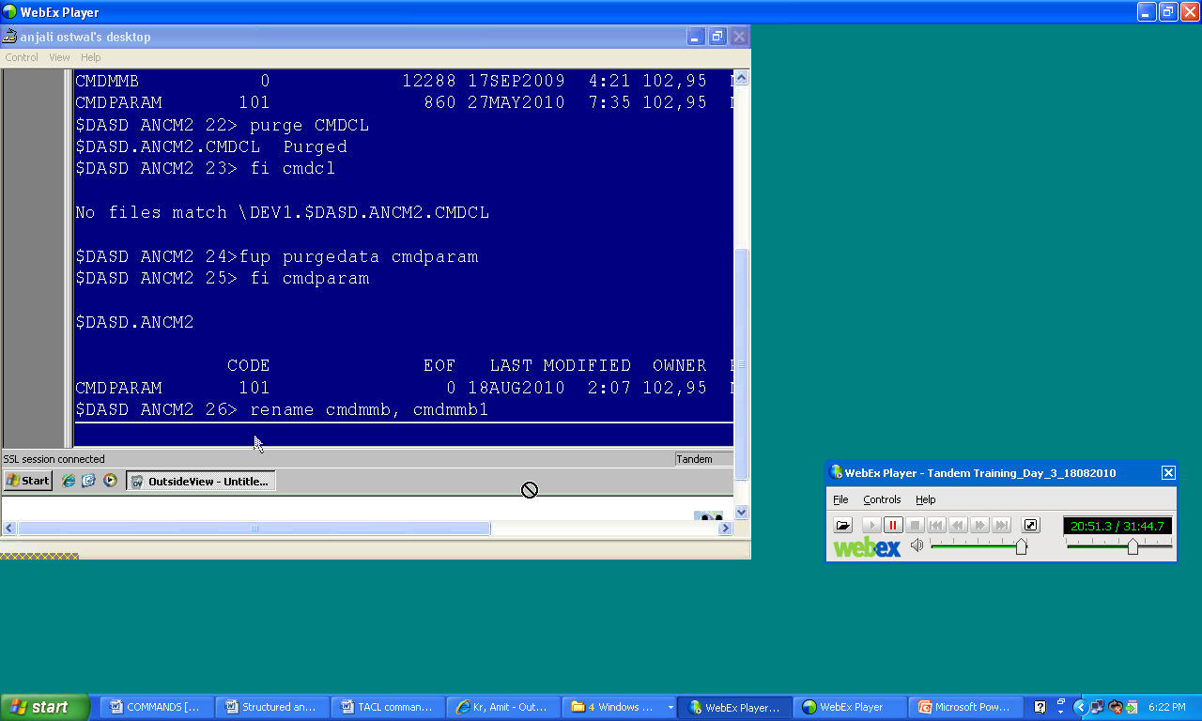

1. TACL Command> **FUP Alter Cmdai, maxextents 110**

(*alter command is used to alter the file attributes. This command is altering file attribute of file “Cmdai”. MaxExtents = 100 earlier now, it will be updated with the value 110*)

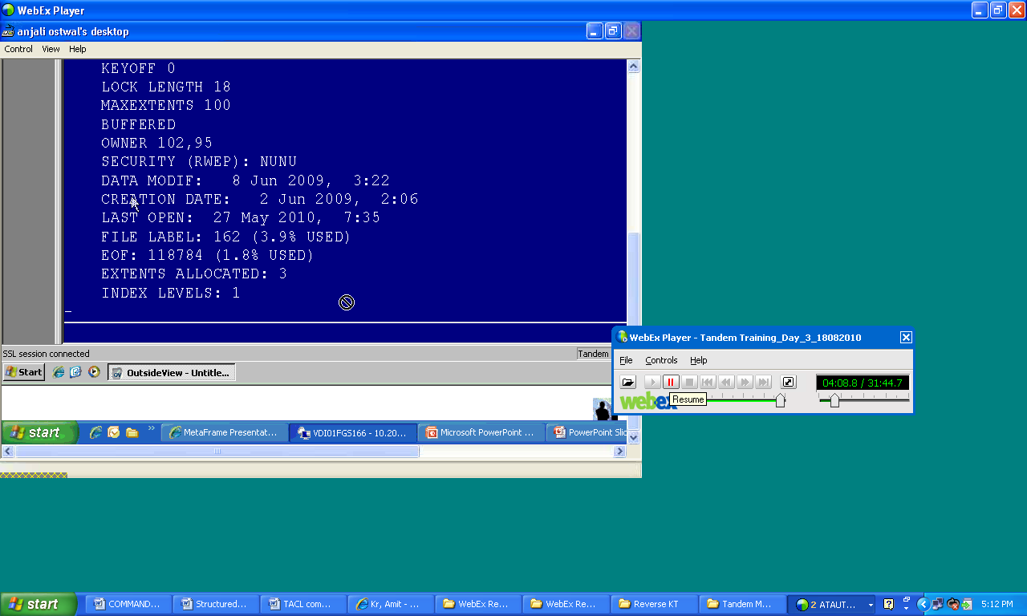

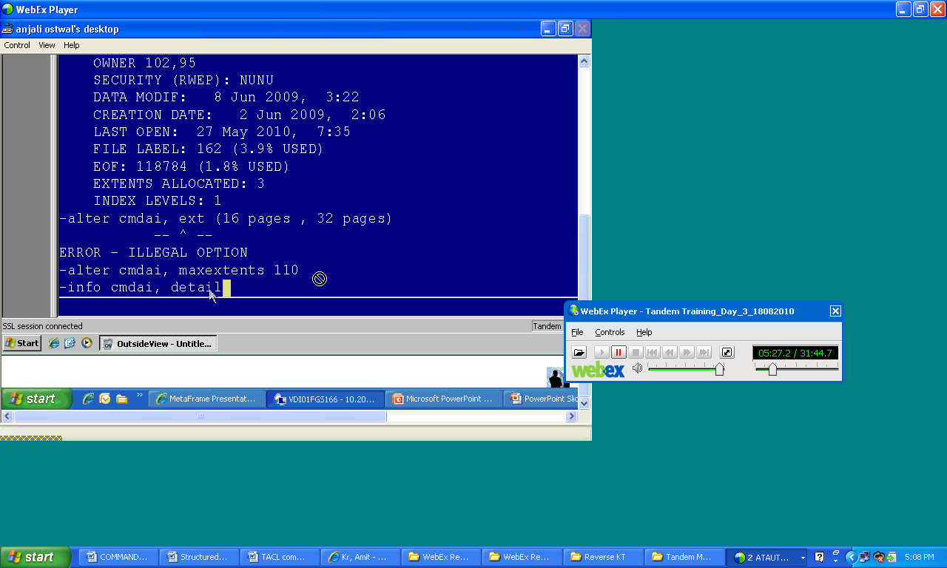

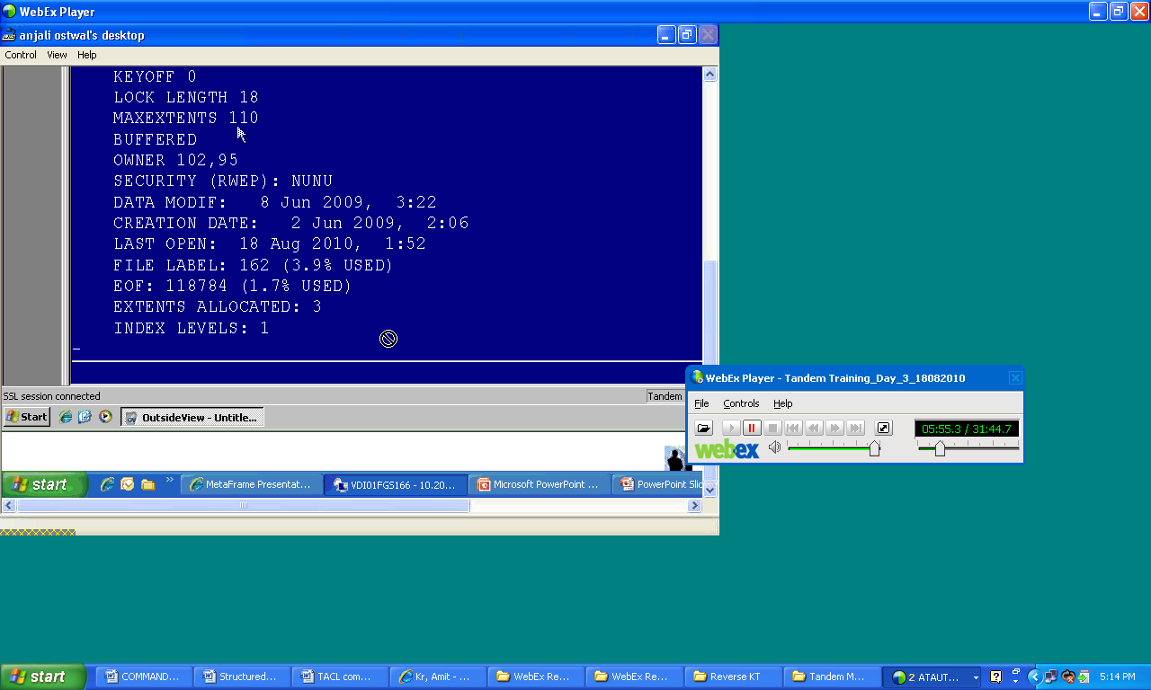

1. TACL Command> FUP Copy CMDAI, , a, share

(FUP Copy command will copy the CMDAI file on the terminal in ASCII format)

FUP Copy = Command

CMDAI = File Name

, , = Destination location is blank as we want to open the file on terminal for reading.

Share = if the file is open then you can open the file on your terminal in share mode.

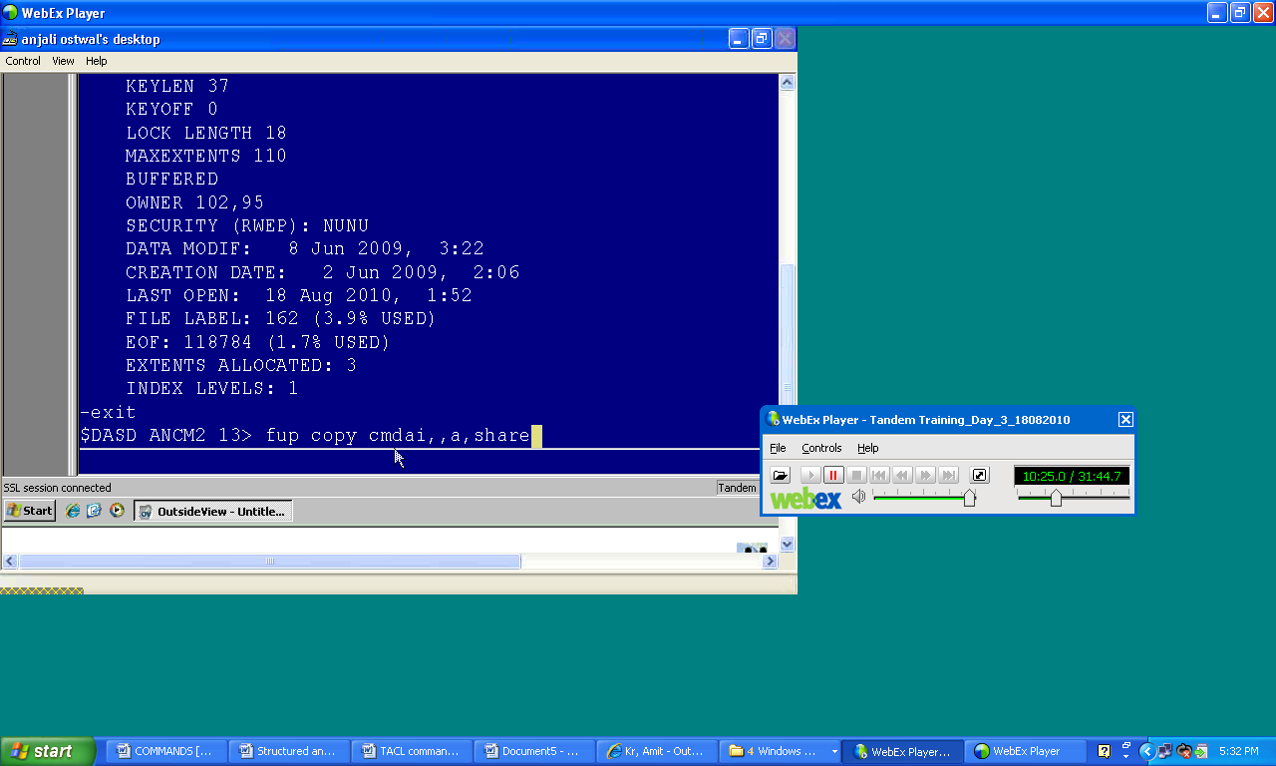

1. TACL Command > **FUP COPY CMDAI, , a, Count 10**

(*this command will display* ***first 10*** *records on the terminal*)

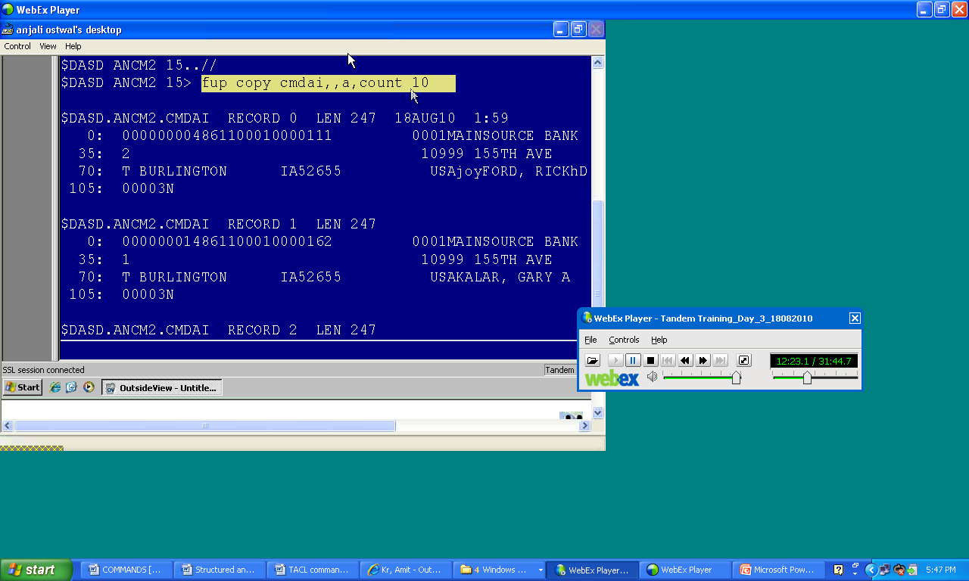

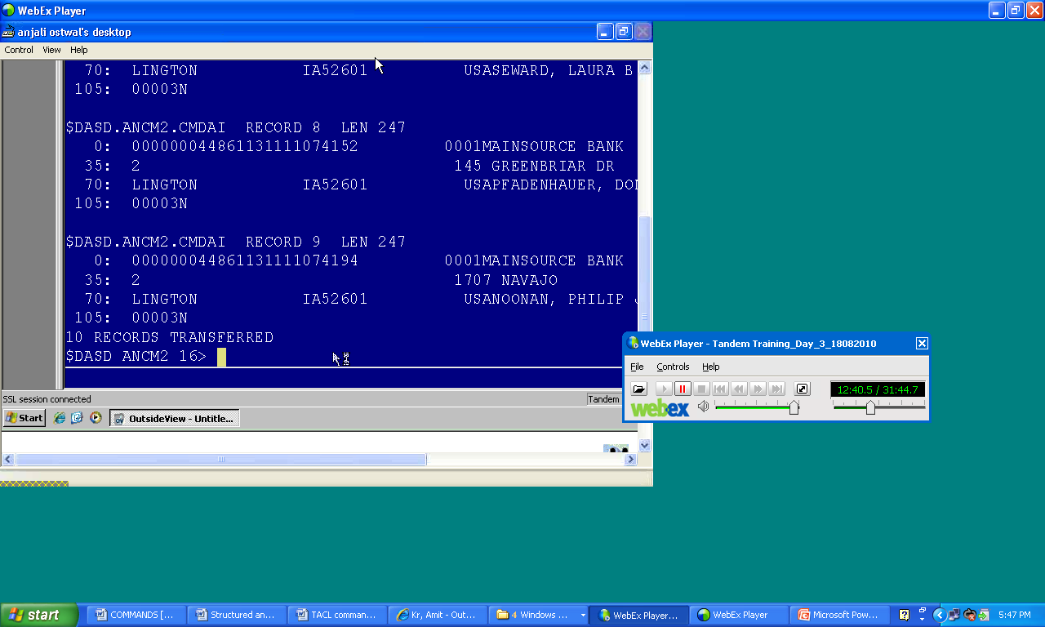

1. TACL Command> **FUP Copy CMDAI, , a, Count 10, First 20**

(*this command will copy. Skipp first 20 records and display next 10 records*)

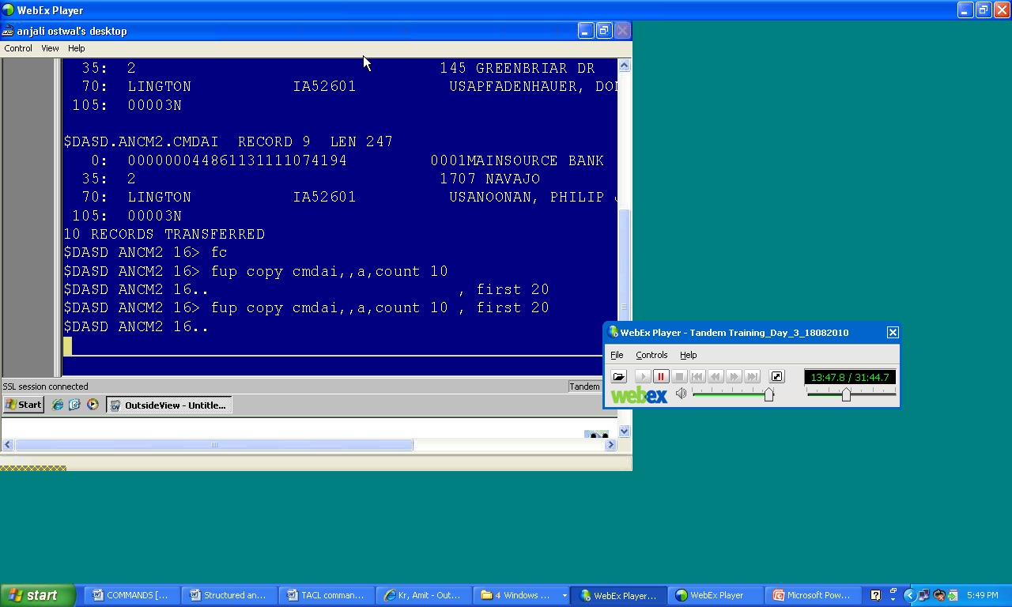

1. TACL Command> Purge <*filename*>

(*this file will purge the file from the system permantely*)

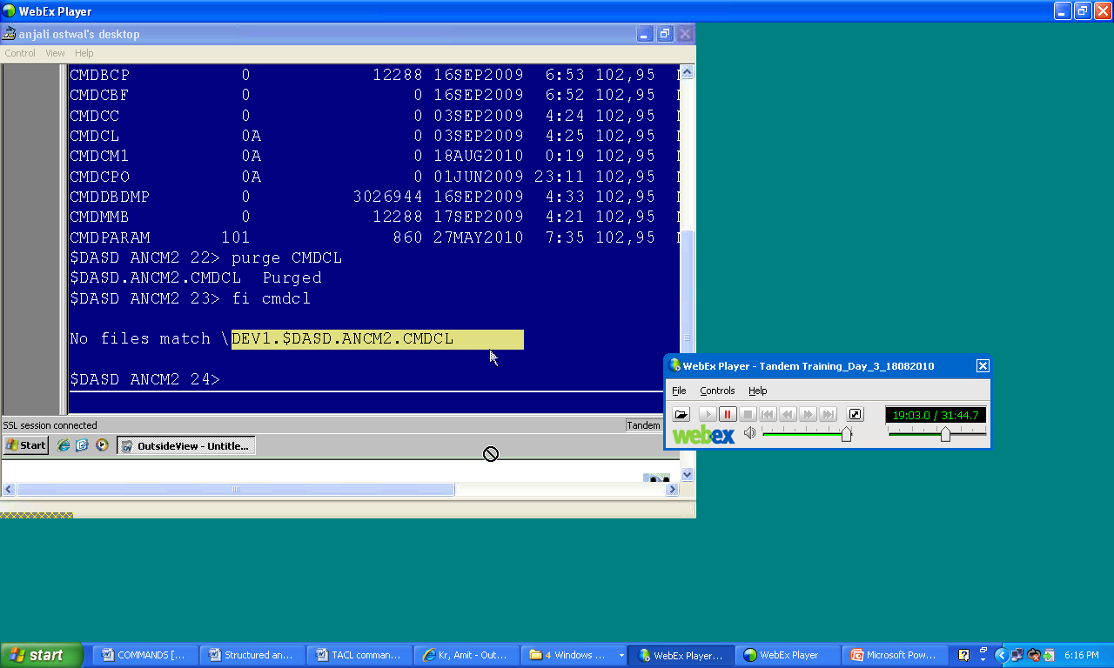

1. TACL Command> FUP PURGEDATA CMDCL (**What Delete command will do**)

(*this command will delete the data from the file CMDCL. If you observe the initial size of the file was 860 bytes after running purgedata command the file size is now 0 bytes*)

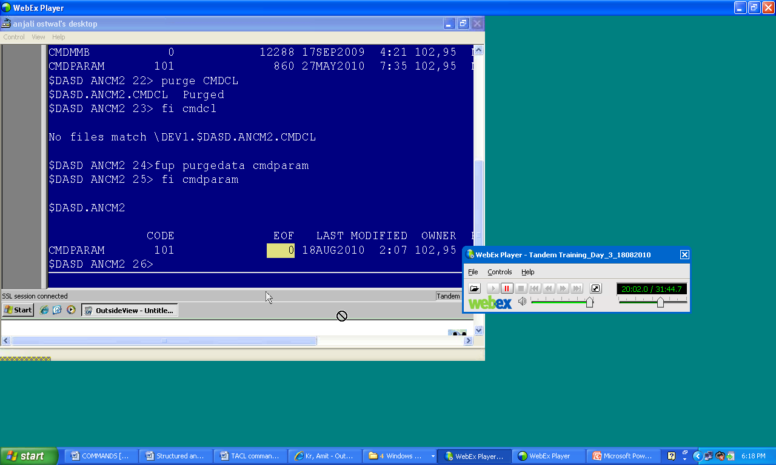

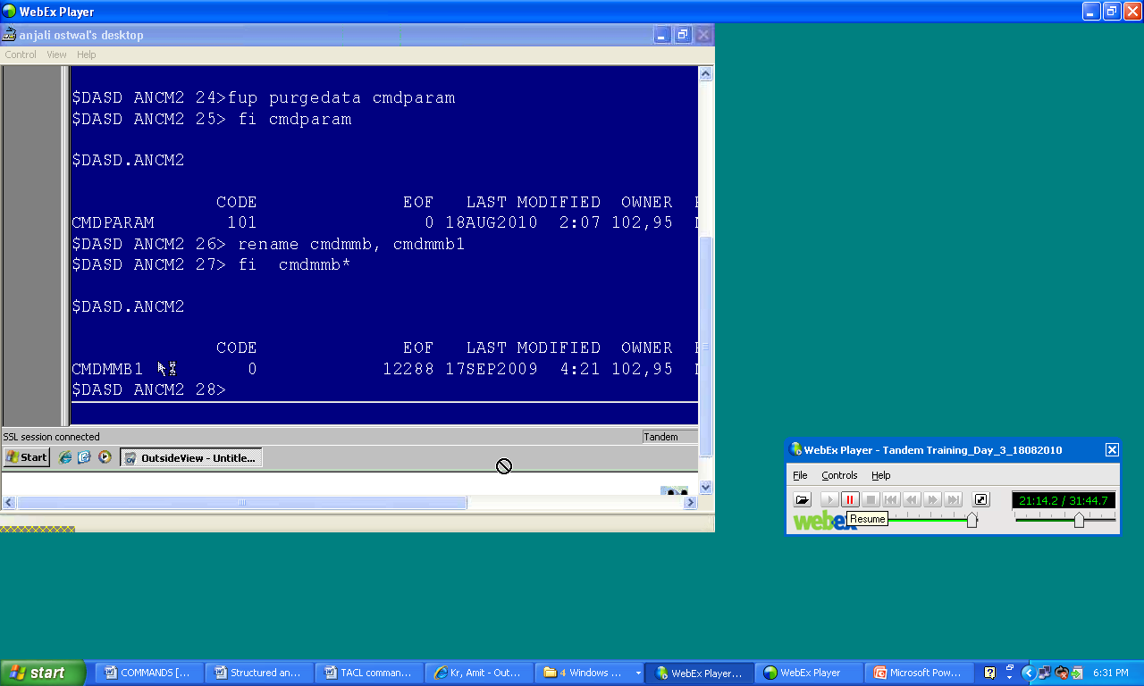

1. TACL Command> FUP listopens $okc.cmdata.cmdcm

(*this command will display all the programs who are accessing this file*)

**PID = Process id, Mode = R, R/W & Share, User id= SD, MyTerm = terminal name, Program = name of the program**

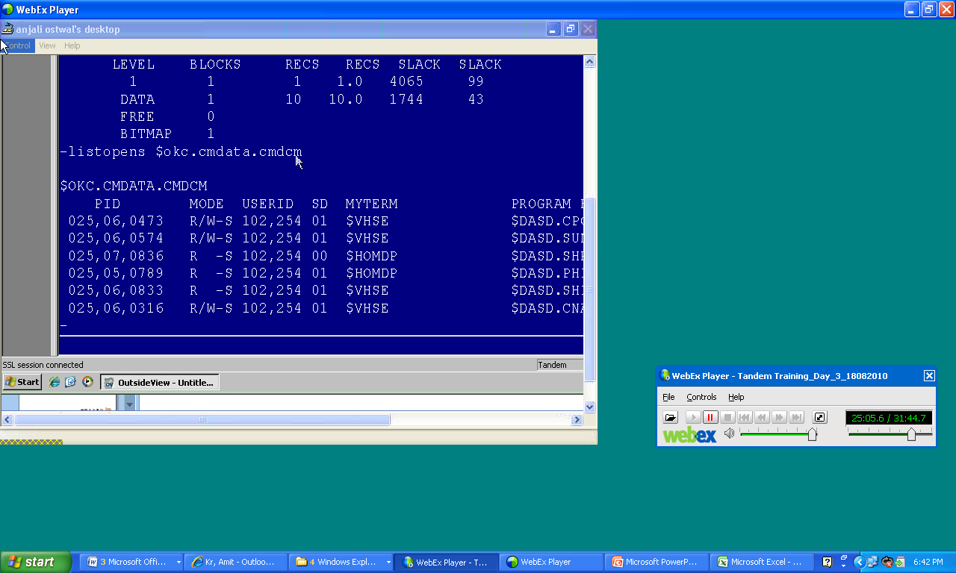

1. Volume $<Volume-Name>

(*this command is used to change the volume*)

1. Volume $<Volume-Name>.<Sub-Volume-Name>

(*this command is used to change the sub-volume*)

1. Attributes to secure a file:

U= User A=**Anyone** - = SuperID

G= **Group** C=**Community**  
O=Owner N=**Network**

TACL Command> FUP Secure <*filename*>, “NONO”

(*this command will provide RWEP rights to Network, Owner, Network and Owner respectively*)

N (*Network*) =Read

O (*Owner*) =Write

N (*Network*) =Execute

O (*Owner*) =Purge

1. TACL Command> **Fup info $okc.cmdata.cmdcp,stat**

(*this command will show the file statics where $okc.cmdata.dmdcp denotes volume, sub-volume and file respectively. Stat will show the file statics*)

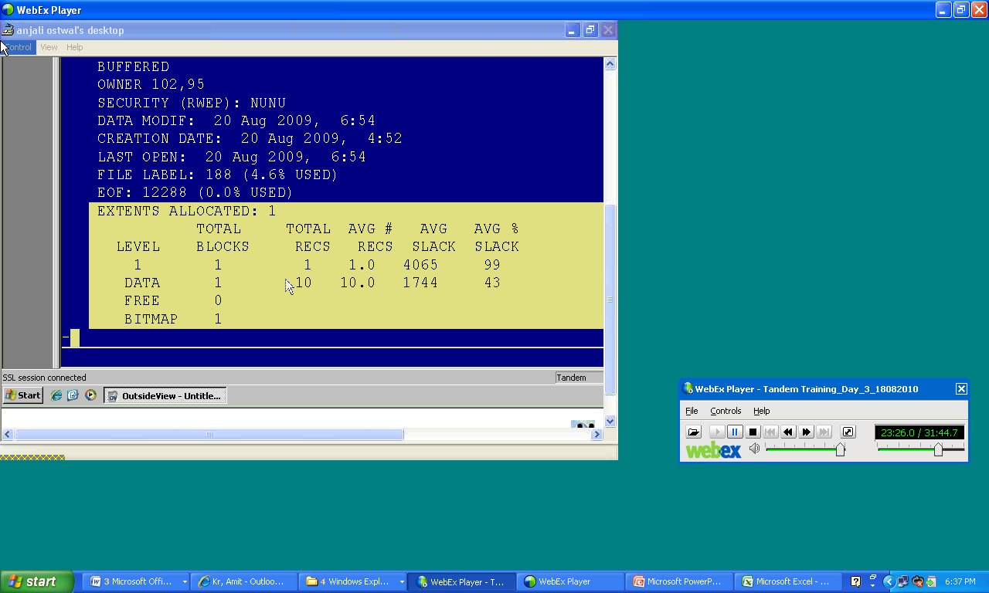

TACL Command> fup info $okc.cmdata.cmdcp,stat

ENSCRIBE (*i.e.* *database*)

TYPE K (*i.e. Key Sequential File*)

FORMAT 1 (*i.e. File Format 1*)

EXT ( 4 PAGES, 32 PAGES ) (*i.e. pages in primary extent and pages in secondary ext.1page = 2048B)*

REC 168 (*i.e. Each* Record will be of 168B)

BLOCK 4096 (i.e. Block 4096B)

KEYLEN 20 (i.e. length of key = 20 )

KEYOFF 0 (*i.e. Keyoffset*)

AUDIT (i.e. auto-commit will not work)

MAXEXTENTS 100

BUFFERED

OWNER 102,82

SECURITY (RWEP): NCCC

DATA MODIF: 24 Aug 2010, 1:34, OPEN

CREATION DATE: 27 Mar 2009, 0:14

LAST OPEN: 24 Aug 2010, 9:20

FILE LABEL: 166 (4.0% USED)

EOF: 163840 (2.5% USED)

EXTENTS ALLOCATED: 4

TOTAL TOTAL AVG # AVG AVG %

LEVEL BLOCKS RECS RECS SLACK SLACK

1 1 38 38.0 3533 86

DATA 38 542 14.3 1639 40

FREE 0

BITMAP 1

IDENTIFICATION DIVISION.  
  
   PROGRAM-ID.  
  
   ENVIRONMENT DIVISION.  
  
   DATA DIVISION.  
  
   WORKING-STORAGE SECTION.  
  
   01 ARRAY.  
  
    02 A PIC 9(3) OCCURS 20 TIMES.  
  
   77 N PIC 9(2).  
  
   77 T PIC 9(3).  
  
   77 I PIC 9(2).  
  
   77 J PIC 9(2).  
  
   77 P PIC ZZ9.  
  
   PROCEDURE DIVISION.  
  
   MAIN-PARA.  
  
      DISPLAY " ENTER ARRAY LENGTH ".  
  
      ACCEPT N.  
  
      MOVE N TO P.  
  
      DISPLAY " ENTER " P " ELEMENTS ".  
  
      PERFORM A-PARA VARYING I FROM 1 BY 1 UNTIL I > N  
  
      PERFORM X-PARA VARYING I FROM 1 BY 1 UNTIL I > N  
  
      DISPLAY " THE ASCENDING ORDER IS ".  
  
      PERFORM D-PARA VARYING I FROM 1 BY 1 UNTIL I > N  
  
      STOP RUN.  
  
   A-PARA.  
  
      ACCEPT A(I).  
  
   X-PARA.  
  
      PERFORM Y-PARA VARYING J FROM 1 BY 1 UNTIL J > N.  
  
   Y-PARA.  
  
      IF ( A(I) < A(J) )  
  
       MOVE A(I) TO T  
  
       MOVE A(J) TO A(I)  
  
       MOVE T TO A(J).     
  
   D-PARA.  
  
      MOVE A(I) TO P.  
  
      DISPLAY P.